Models for synchrophasor with step discontinuities in magnitude and phase: estimation and performance

Marcelo B. Martins, Renata de Barros e Vasconcellos, and Paulo A. A. Esquef, Member, IEEE

[1]

***Abstract —* This work proposes an alternative method to assess the calibration of phasor measurements units (PMUs) under conditions of step discontinuities in magnitude or phase. Two parametric mathematical models, which are proposed to represent these signals, are fitted to signal samples via an iterative numerical method. The proposed approach does not require any time adjustment of the analysis window to skip the discontinuity. The estimated parameters can be used to calculate a reference phasor with an appropriate definition. Moreover, accurate estimates of the location and magnitude of the discontinuities are provided.**

***Index Terms —* Calibration, dynamic tests, phasor measurement units, synchrophasor, uncertainty.**

# INTRODUCTION

T

he dynamic behavior of modern electric grid demands testing the performance of phasor measurement units (PMUs) under magnitude steps and phase steps [1]. The accuracy of those measurements depends on the reference values provided by PMU calibration systems. Recent developments towards the calibration of PMUs for distribution grids demand lower uncertainty levels than the first systems, which were designed for the context of transmission grids [2]. The calibration process depends on generating and sampling synchronized waveforms, from which reference phasors are compared to the values provided by the PMU under test. The phasor which phase is related to an ideal cosine function with maximum centered in the Universal Time Code (UTC) second is called a synchrophasor. PMUs also provide estimates of frequency and rate of change of frequency (ROCOF) at a given report rate.

For the estimation of synchrophasors, a stationary phasor waveform can be curve fitted with a steady state sinusoidal function with good accuracy. Methods to estimate parameters of signals with slowly varying frequency, magnitude or phase, for PMU calibration purposes, are also presented in [2] and [3]. Typical variations in parameters or nonlinearities can be modeled by low order Taylor series expansion. Then, iterative procedures are used to estimate the model parameters.

In the specific case of an observed phasor disturbed by a step discontinuity in magnitude or phase, the estimation using an underlying steady state model is inappropriate and does not guarantee convergence nor accuracy. Besides, there is a lack of definition of what the reference phasor should be. To overcome this difficulty, the method used in [3] adjusts the timestamp and position of the analysis window to skip the discontinuity and set the phasor estimates where the discontinuity occurs with those of obtained from the previous or following window. That way, it avoids the mathematical modelling of a step discontinuity and considers the reference value coming from the steady state.

The mentioned procedures are designed to calibrate PMUs, and may be not detailed enough to evaluate the performance of calibration systems. Methods for a more detailed analysis of calibration systems under step conditions are proposed in [4]. The authors use a pointwise root mean squared error for the performance evaluation of the investigated phasor estimators.

Although not trying to break the stationary paradigm of the phasor representation of a signal, we propose an alternative approach to evaluate the measurements of PMU calibration systems. For that, this extended version of [5] offers the following contributions:

1) Aiming at having accurate phasor estimates under transient conditions, we propose signal models that account for step discontinuities in magnitude or phase, incorporating representations of both the transient and the phasor.

2) Ways to estimate the parameters:

a) To use the instantaneous frequency as provided by the Hilbert transform of the perturbed phasor signal to estimate the instant of the step discontinuity;

b) To use a nonlinear least-square method (NL-LS) to estimate the other parameters of the models proposed in 1), provided the step instant estimate.

3) Proposition of single phasor estimate for transient situations, which can be used as reference values for PMU calibrations and easily implemented in the existing systems, in place of traditional estimation schemes. The proposed method depends on the estimation of parameters of an underlying model.

4) A preliminary evaluation of a laboratory system intended to be a PMU calibrator based on the aforementioned methods.

In order to assess the contribution to the uncertainty of the calibration system, we made simulations to obtain the numerical errors of each numerical method. In addition to this introduction, the paper is organized as follows: in section II, we present the mathematical background related to the proposed models for dynamic signals with magnitude or phase steps; the intermediary phasor definitions; and the basic concepts of the Hilbert transform and of the NL-LS method. In section III, we describe the Monte Carlo simulations run to analyze the numerical errors of each method. In section IV, we detail the Laboratory measurements devised to evaluate the use of the proposed system for PMU calibration. Finally, in section V, we discuss the attained results and draw conclusions on the reported investigation.

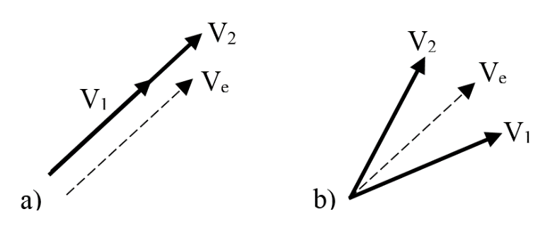

Fig. 1 Transitioning phasors for a) magnitude step, b) phase step

# Mathematical Background

## Mathematical models for dynamic signals

A pure sinusoidal waveform with one magnitude step, located at can be modeled in continuous time

, (1)

where is the step function. A similar model for the phasor waveform with one phase step is

, (2)

where the step function is used as an idealization of a fast transient in magnitude or phase occurring at the instant , where is the signal nominal magnitude, is a decimal value representing the magnitude change, is the amplitude of the phase step, is the angular frequency, is the initial phase, and represents interfering noise. Provided a sufficiently accurate estimate of , the set of parameters can then be adjusted to obtain a waveform that best fits the data received by the calibration system sampler,. Given a prescribed signal to noise ratio (SNR) in dB, for a zero mean gaussian white noise, the variance of noise is

(3)

where is the standard deviation of the signal .

## Reference phasor values

After one estimates the model parameters, the problem of obtaining one phasor that represents the waveform arises. Instead of considering the values estimated from the analysis windows adjacent to the transient, one alternative proposal could be an intermediate value for magnitude or phase. The concept is illustrated in Fig. 1, where the phasor represents the waveform during an initial steady state, is a phasor that could be possibly representative of an intermediate state during the occurrence of a magnitude or phase step, and represents the signal in the final steady state condition. (In Fig. 1-a), is taken off the axis only for visualization purposes.)

Intermediate phasor estimates can be obtained, for example, using a weighted means out of the estimated model parameters. Using the notation to represent an estimate of , for any , for a waveform with magnitude step described by (1), the estimated intermediate phasor would be

; (5)

and for a waveform with a phase step test described by (2), the intermediate phasor would be

. (6)

## Instantaneous frequency via Hilbert transform

Hilbert transform has been used to estimate instantaneous frequency (IF) of narrowband monocomponent signals, which is the case of ideal electric network phasor components. There are various applications of IF estimation reported in the literature, e.g., characterization of electric disturbances [6] and detection of edits in audio signals that bear the electric network frequency [7]. Anomalous perturbations on the IF can flag the occurrence of discontinuities in the signal. The time instant they happened can be estimated via appropriate amplitude threshold schemes. The concept is shown in Fig. 2 and Fig. 3.

Given a real narrowband monocomponent signal , let be called the analytic signal associated to , defined as

, (7)

where

(8)

is the Hilbert transform of . If is expressed in the polar form

(9)

, (10)

, (11)

the instantaneous frequency (IF) can be defined as

. (12)

The discrete implementation of can be done with the fast fourier transform (FFT). [ref]

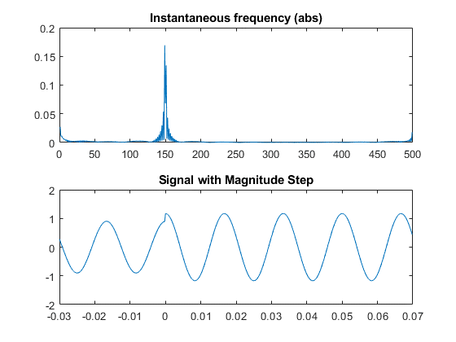

Fig. 2 - Instantaneous frequency of signal with one magnitude step

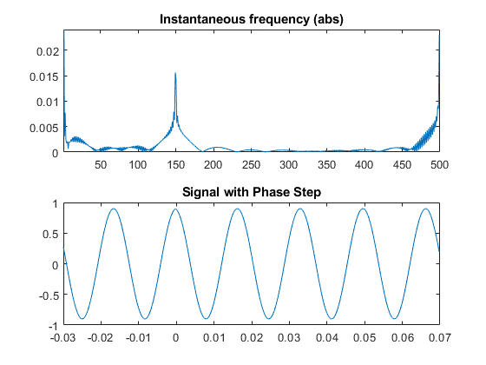

Fig. 3 - Instantaneous frequency of signal with one phase step

## Model Estimation via Levenberg-Marquardt

Consider samples from a sequence which can be either generated via computational simulation or sampled from measured real phenomenon, with uniform sampling period . One wishes to fit the models (see Section II) with parameters to For that, one can define the error cost function

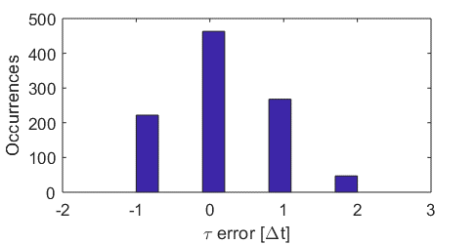

Fig. 4 - Histogram of errors in step instant estimation

, (4)

and try to solve the minimization problem

The estimation of phasor parameters considering variations in frequency within the model requires dealing with a non-linear function. Existing calibration systems solve this problem for steady-state signals through low order Taylor linearization [3], or using directly some non-linear minimization algorithm, e.g., Levenberg-Marquardt (LM) [4].

The Levenberg-Marquardt (LM) algorithm is an iterative technique for nonlinear minimization problems. It combines the Gauss-Newton method and the steepest descent, being very useful when the size of the algorithm step cannot be obtained in a closed form. Such NL-LS methods can reach local minima and need a convex cost function.

Explicar mais um pouco e colocar referencia

Equações

Criterios de convergencia

Aproximação numérica da derivada por diferenças centrais

# Numerical Simulations

We performed Monte Carlo simulations with 1000 runs for each set point, to estimate the errors obtained with the numerical computation of the reference values. These errors will be considered as an uncertainty component in the overall process.

The input signals were digitally generated, with all nominal parameters prescribed in the standard [1] and random values representative of expected uncertainties in each parameter. The signals were created based on (1) and (2) with a 5 kHz sampling frequency, with a duration of 0.1 s. The nominal values are summarized in Table I, with their respective uncertainties used in simulations.

TABLE I

Nominal values and uncertainties for simulations

|  |  |  |  |  |  |
| --- | --- | --- | --- | --- | --- |
| **Parameter** |  |  |  |  |  |
| **Nominal** | 1 Vp | ± 0.1 | ± 10° | 60 Hz | 360°, ±120° |
| **U[%]** | 1 | 1 | 1 | 0.05 | 1 |

## Step instant estimation with Hilbert transform

The peaks were detected taking the maximum value of the IF subtracted by its median value. If we use an ideal signal without uncertainties in the parameters and nominal frequency, for a total duration of the window T, , and , (with additive white noise drawn from a uniform distribution), the maximum absolute errors are not greater than .

In a second simulation, designed to represent a more realistic situation, we allowed 500 ppm variation in frequency and 1% variation in the other parameters, all under a uniform distribution. The maximum errors obtained are not greater than for a , with additive zero mean white gaussian noise. The distribution of errors (in units) for positive magnitude step of 10% is shown in a histogram in Fig. 4. Similar histograms were obtained for negative magnitude steps and phase steps of ± 10°, with the same results.

## Parameters estimation with non-linear least squares

For the uncertainty analysis reported in this subsection, at each Monte Carlo run, the signal is generated with uncertainties added to the parameters, drawn from a uniform distribution centered in the nominal values, as shown in Table I.

In the iterative LM algorithm, the model parameters are initiated at the nominal values, and the optimization procedure seeks for the minimum point of which is reached at the actual values of the parameters.

Criterios de convergencia

The final estimates have significantly lower errors than the initial values, despite having some sensitivity to noise. As an example, the maximum errors obtained are shown in Table II for magnitude step tests and Table III for phase step tests.

Substituir esta analise por:

Frequencia

Magnitude under phase steps

Phase under magnitude steps

TABLE II

Maximum errors for magnitude step tests [ppm]

|  |  |  |  |  |
| --- | --- | --- | --- | --- |
| **SNR** |  |  |  |  |
| 97 | 1.1 | 19 | 0.07 | 0.34 |
| 95 | 1.6 | 22 | 0.11 | 0.49 |
| 93.5 | 1.6 | 27 | 0.11 | 0.49 |
| 92.5 | 1.7 | 31 | 0.13 | 0.58 |
| 90.5 | 2.7 | 42 | 0.19 | 0.83 |

TABLE III

Maximum errors for phase step tests [ppm]

|  |  |  |  |  |
| --- | --- | --- | --- | --- |
| **SNR** |  |  |  |  |
| 97 | 0.80 | 20 | 0.15 | 0.72 |
| 95 | 0.96 | 24 | 0.21 | 1.1 |
| 93.5 | 1.1 | 28 | 0.22 | 1.2 |
| 92.5 | 1.4 | 34 | 0.25 | 1.5 |
| 90.5 | 1.7 | 40 | 0.31 | 2.1 |

## Estimation of intermediate phasors

For signals digitally generated with the uncertainties indicated in Table I, and also considering maximum errors of ± in the estimation of , the intermediate phasors calculated with (5) and (6) were compared to nominal values to obtain magnitude and phase maximum errors.

For the magnitude step tests, with additive white gaussian noise (), in every prescribed situation, the standard deviation of errors obtained for the estimates of magnitude were not greater than , and for the estimates of phase the standard deviation of errors were not greater than . There is some sensitivity to noise, shown in Fig. 6, in function of the step instant of occurrence.

# Laboratory measurements

Aiming at validating the proposed method with real signals, several measurements were made using one digital sampling voltmeter (DSVM) and one arbitrary waveform generator (AWG), controlled by a personal computer (PC) via GPIB. The connections are shown in the block diagram of Fig. 7.

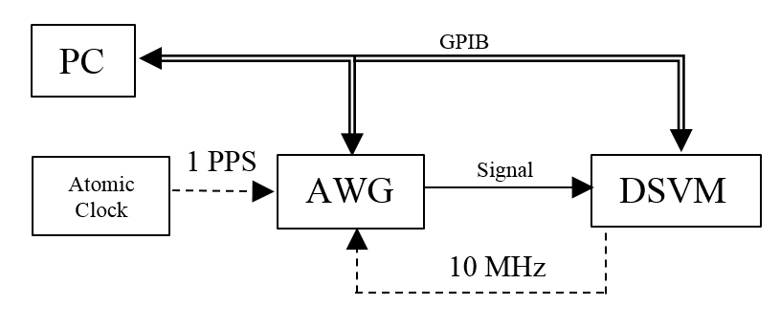

Fig. 6 - Block Diagram

The same waveforms used in simulations are reproduced by the AWG, with a nominal output of , and sampled by the DSVM. Both are triggered with a 1 PPS (pulse per second) signal, coming from an atomic clock, so we can control the initial phase. The internal clock from the DVM is used as an external 10MHz reference signal by the generator. 5000 samples are taken during 1 s and stored in the DVM´s internal memory.

The standard [1] establishes that the synchrophasors must be obtained related to the center of a window. Setting 500 samples/window, the first complete window will happen after 250 samples, after which we have 9 windows containing 6 cycles of 60Hz. The steps of magnitude or phase occur in the 5th window, as shown in Fig. 8. According to the procedure for equivalent sampling, the instants of occurrence of the steps are a set of equally spaced intervals .

For the windows with steady state waveforms, the same fitting algorithm used in [3] is used to obtain the synchrophasors and frequency estimates.

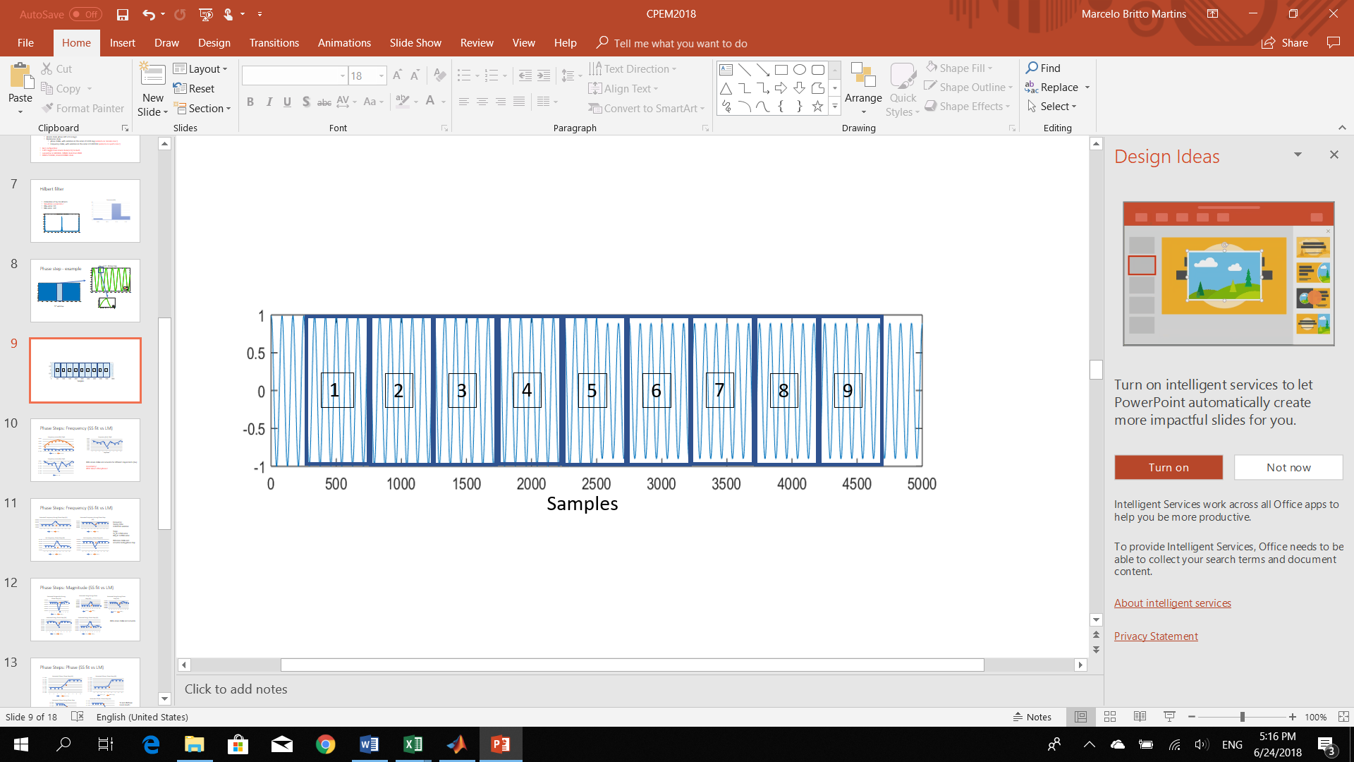

Fig. 8 - Magnitude step occurrence in the 5th window

For the 5th window, the intermediate phasors were calculated using (5) or (6), after obtaining the parameters using the Hilbert algorithm for the step instant, and the-LM algorithm for the others. The frequency was obtained directly from the LM estimation.

The estimates of step instant were not greater than 2, inside the expected uncertainty. The other parameters require a more detailed analysis.

## Intermediate magnitude and phase

The system is capable of providing intermediate values for magnitude and phase, as can be seen in Fig. 9 and Fig. 10, respectively. Each series of data show different step instant occurrences in the 5th timestamp, in percentage of the window period .

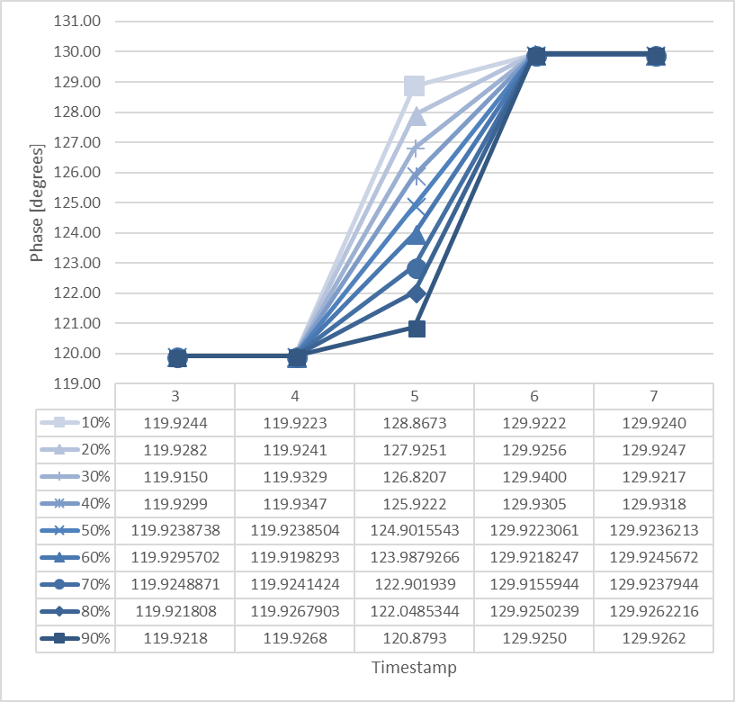

Fig. 10 Intermediary Phase. Phase positive step of 10 degrees, starting at 120 degrees.

## Frequency

Frequency estimates for the analysis windows with steady state signals present standard deviation of errors not greater than (0) from the nominal. When submitted to magnitude steps, the system present standard deviations from the nominal of about (), as can be seen in Fig. 11, where the vales for each plot are taken with different step instant occurrences.

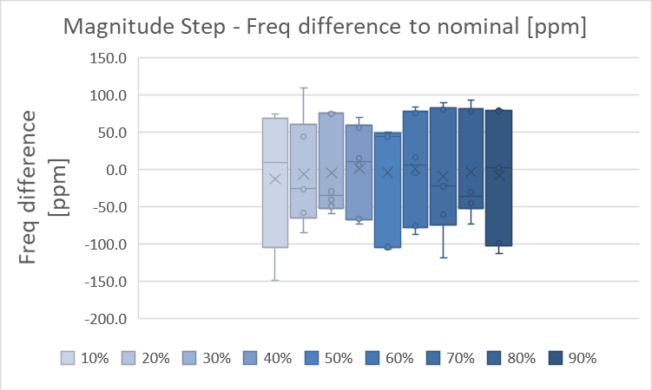

Fig. 11 Frequency variation during magnitude tests in function of the step instant.

The worst frequency variations are observed when the system is submitted to phase steps. Shown in Fig. 12, standard variations of about ( can be seen when the phase step occurrence is near the borders of the window, up to (), with the phase step in the middle of the window.

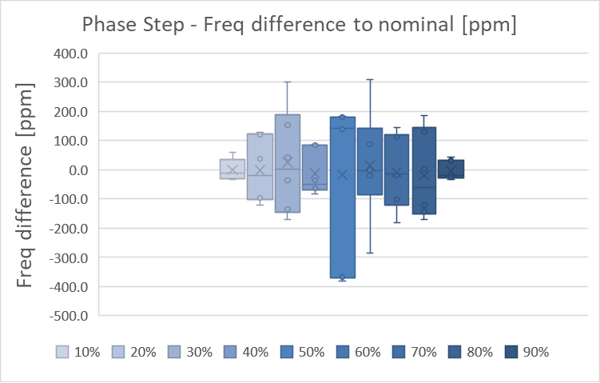

Fig. 12 Frequency variation during phase steps in function of the step instant.

## Magnitude during phase step

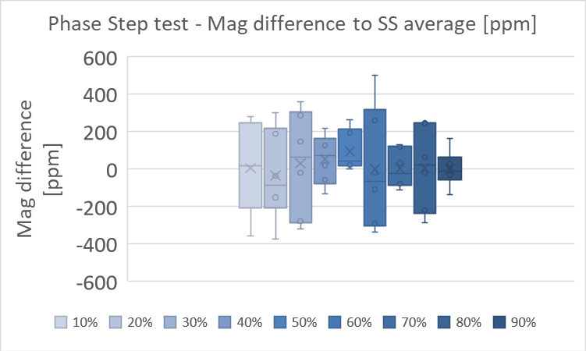

Fig. 13 Magnitude variation during phase steps in function of the step instant of occurrence

During steady state conditions, the magnitude have a standard deviation not greater than . When submitted to phase steps, the magnitude differences to the average values obtained from the steady state phasors show higher values, as shown in Fig. 13, with a standard deviation of .

## Phase during magnitude step

During steady state conditions, the phase estimates have standard deviations with high dependency on the step occurrence. (fazer grafico ou tabela)

Fig. 14 Phase variation during magnitude steps in function of the step instant of occurrence.

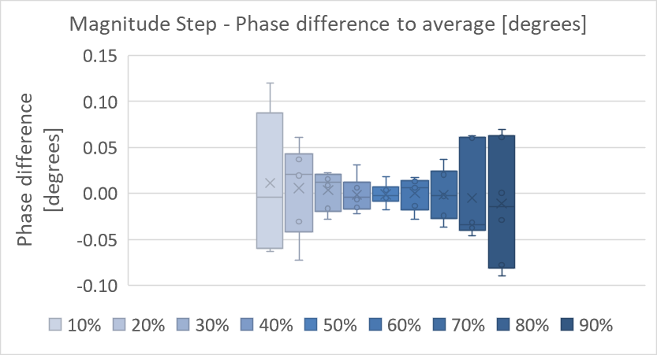

The estimates of phase during magnitude step presents higher variations, especially when the step is not centered in half the window, even higher as far as the step occurrence is from the center of the window, as can be seen in Fig. 14. ~~Phase errors can be of about degrees, but it goes down to degrees if .~~

# Conclusion

Models for phasor signals disturbed by magnitude and phase step discontinuity were proposed, in the context of assessment of PMU calibration systems in transient conditions. Estimation of the model parameters via a nonlinear least-squares method was outlined. The proposed approach tackles the estimation of the step discontinuities in the phasor signal observed within an analysis window, instead of dodging the problem. Moreover, single phasor parameters are proposed for transient conditions.

The estimation accuracy of each parameter was obtained under different noise conditions and uncertainties forced upon the model used to generate the test signals. Cross-correlated uncertainties were found, which point out to the need of a deeper investigation and the possibility of further improvements in the estimation performance.

Within the limits reported, the proposed method can give reliable and accurate results to be used in PMU calibration systems, avoiding procedures to adjust windows and time-stamps around the instant of step occurrence.

Acknowledgment

I would like to thank Allen Goldstein, for the valuable comments and guidelines.

References

[1] *IEEE Standard for Synchrophasor Measurements for Power Systems*, IEEE Std C37.118.1-2011*,* Dec. 2011

[2] D. Colangelo *et al*., "Architecture and characterization of a calibrator for PMUs operating in power distribution systems," *2015 IEEE Eindhoven PowerTech*, Eindhoven, 2015.

[3] Y. H. Tang, G. N. Stenbakken and A. Goldstein, "Calibration of Phasor Measurement Unit at NIST," in *IEEE Transactions on Instrumentation and Measurement*, vol. 62, no. 6, pp. 1417-1422, June 2013.

[4] FRIGO, Guglielmo et al., “Definition of accurate reference synchrophasors for static and dynamic characterization of PMUs.” in *IEEE Transactions on Instrumentation and Measurement*, vol. 66, n. 9, p. 2233-2246, 2017.

[5] ESTE MESMO

[6] Caciotta, M., et al. "Detection of short transients and interruptions using the Hilbert transform." in *Proc. 19th IMEKO World Congr. Fundam. Appl. Metrol.. 2009*.

[7] Edit Detection in Speech Recordings via Instantaneous Electric Network Frequency Variations

Referencias de Guilherme e renata, na parte de incertezas estimadas

Ver outras

**First A. Author** (M’76–SM’81–F’87) and all authors may include biographies. Biographies are often not included in conference-related papers. This author became a Member (M) of IEEE in 1976, a Senior Member (SM) in 1981, and a Fellow (F) in 1987. The first paragraph may contain a place and/or date of birth (list place, then date). Next, the author’s educational background is listed. The degrees should be listed with type of degree in what field, which institution, city, state, and country, and year the degree was earned. The author’s major field of study should be lower-cased.

The second paragraph uses the pronoun of the person (he or she) and not the author’s last name. It lists military and work experience, including summer and fellowship jobs. Job titles are capitalized. The current job must have a location; previous positions may be listed without one. Information concerning previous publications may be included. Try not to list more than three books or published articles. The format for listing publishers of a book within the biography is: title of book (publisher name, year) similar to a reference. Current and previous research interests end the paragraph.

The third paragraph begins with the author’s title and last name (e.g., Dr. Smith, Prof. Jones, Mr. Kajor, Ms. Hunter). List any memberships in professional societies other than the IEEE. Finally, list any awards and work for IEEE committees and publications. If a photograph is provided, it should be of good quality, and professional-looking. Following are two examples of an author’s biography.

**Second B. Author** was born in Greenwich Village, New York, NY, USA in 1977. He received the B.S. and M.S. degrees in aerospace engineering from the University of Virginia, Charlottesville, in 2001 and the Ph.D. degree in mechanical engineering from Drexel University, Philadelphia, PA, in 2008.

From 2001 to 2004, he was a Research Assistant with the Princeton Plasma Physics Laboratory. Since 2009, he has been an Assistant Professor with the Mechanical Engineering Department, Texas A&M University, College Station. He is the author of three books, more than 150 articles, and more than 70 inventions. His research interests include high-pressure and high-density nonthermal plasma discharge processes and applications, microscale plasma discharges, discharges in liquids, spectroscopic diagnostics, plasma propulsion, and innovation plasma applications. He is an Associate Editor of the journal *Earth*, *Moon*, *Planets*, and holds two patents.

Dr. Author was a recipient of the International Association of Geomagnetism and Aeronomy Young Scientist Award for Excellence in 2008, and the IEEE Electromagnetic Compatibility Society Best Symposium Paper Award in 2011.

**Third C. Author, Jr.** (M’87) received the B.S. degree in mechanical engineering from National Chung Cheng University, Chiayi, Taiwan, in 2004 and the M.S. degree in mechanical engineering from National Tsing Hua University, Hsinchu, Taiwan, in 2006. He is currently pursuing the Ph.D. degree in mechanical engineering at Texas A&M University, College Station, TX, USA.

From 2008 to 2009, he was a Research Assistant with the Institute of Physics, Academia Sinica, Tapei, Taiwan. His research interest includes the development of surface processing and biological/medical treatment techniques using nonthermal atmospheric pressure plasmas, fundamental study of plasma sources, and fabrication of micro- or nanostructured surfaces.

Mr. Author’s awards and honors include the Frew Fellowship (Australian Academy of Science), the I. I. Rabi Prize (APS), the European Frequency and Time Forum Award, the Carl Zeiss Research Award, the William F. Meggers Award and the Adolph Lomb Medal (OSA).

1. This paragraph of the first footnote will contain the date on which you submitted your paper for review. It will also contain support information, including sponsor and financial support acknowledgment. For example, “This work was supported in part by the U.S. Depart­ment of Com­merce under Grant BS123456.”

   The next few paragraphs should contain the authors’ current affiliations, including current address and e-mail. For example, F. A. Author is with the National Institute of Standards and Technology, Boulder, CO 80305 USA (e-mail: author@ boulder.nist.gov).

   S. B. Author, Jr., was with Rice University, Houston, TX 77005 USA. He is now with the Department of Physics, Colorado State University, Fort Collins, CO 80523 USA (e-mail: author@lamar.colostate.edu).

   T. C. Author is with the Electrical Engineering Department, University of Colorado, Boulder, CO 80309 USA, on leave from the National Research Institute for Metals, Tsukuba, Japan (e-mail: author@nrim.go.jp).